Program 1
//Program to test values of pre & post: increment & decrement.

#include<stdio.h>
int main(){
float x=5.0, b=5.0, a;

a= ++x + ++b; // a=12 , x=6, b=6
printf("A = %f\n",a);
a= ++x - ++b; // a=0 , x=7, b=7
printf("A = %f\n",a);
a= ++x * ++b; // a=64, x=8, b=8
printf("A = %f\n",a);
a= ++x / ++b; // a=1, x=9, b=9
printf("A = %f\n",a);

printf(“\n”);
x=5.0, b=5.0;

a= x++ + ++b; // a=11, x=5, b=6
printf("A = %f\n",a);
a= x++ - ++b; // a=-1, x=6, b=7
printf("A = %f\n",a);
a= x++ * ++b; // a=56, x=7, b=8
printf("A = %f\n",a);
a= x++ / ++b; // a=0.888, x=8, b=9
printf("A = %f\n",a);

printf("\n");
x=5.0, b=5.0;

a= ++x + b++; // a=11, x=6, b=5
printf("A = %f\n",a);
a= ++x - b++; // a=1, x=7, b=6
printf("A = %f\n",a);
a= ++x * b++; // a=56, x=8, b=7
printf("A = %f\n",a);
a= ++x / b++; // a=1.125, x=9, b=8
printf("A = %f\n",a);

printf("\n");
x=5.0, b=5.0;

a= x++ + b++; // a=10, x= 5, b=5
printf("A = %f\n",a);
a= x++ - b++; // a=0, x=6, b=6
printf("A = %f\n",a);
a= x++ * b++; // a=49, x=7, b=7
printf("A = %f\n",a);
a= x++ / b++; // a=1, x=8, b=8
printf("A = %f\n",a);
}

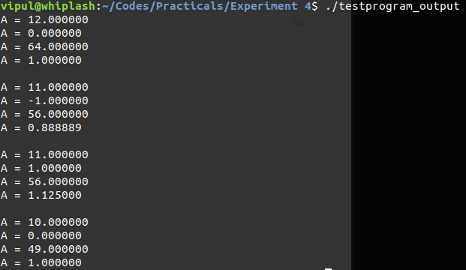
Program 2
// Program to perform bitwise operations

#include<stdio.h>

int main(){
int p,q,r,a=13,b=14;
p=a&b;
q=a|b;
r=a^b;
printf("%d\n%d\n%d\n",p,q,r);

}

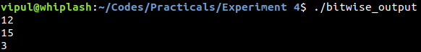
Program 3
//Program to

